**Module 3 :JWT-HandsOn**

# **Hands on: Create authentication service that returns JWT**

**Objectives:**

You’ll build a secure REST API that:

1. Authenticates users using Basic Auth.
2. Issues JWT tokens after authentication.
3. Secures APIs by validating the JWT in each request using a filter.

**Procedure:**

**Step 1: Add Dependencies in pom.xml**

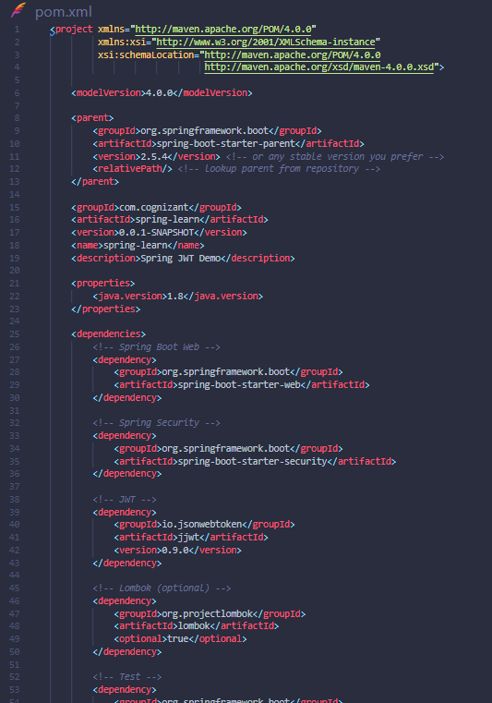

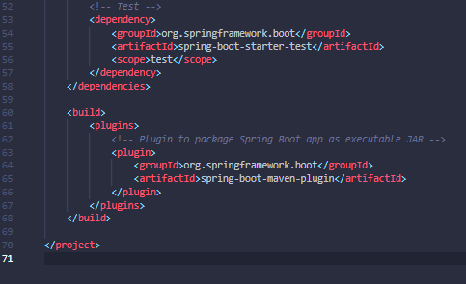

**Step 2: Create AuthenticationController**

* AuthenticationController.java

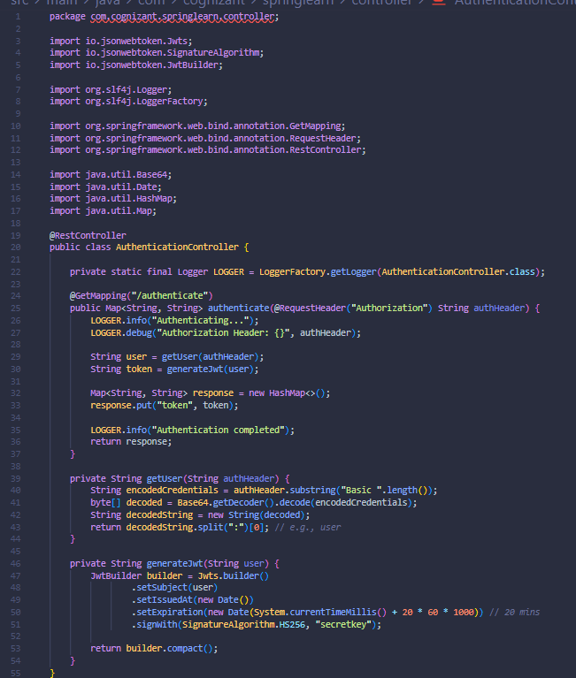

**Step 3: Update Security Configuration**

* SecurityConfig.java

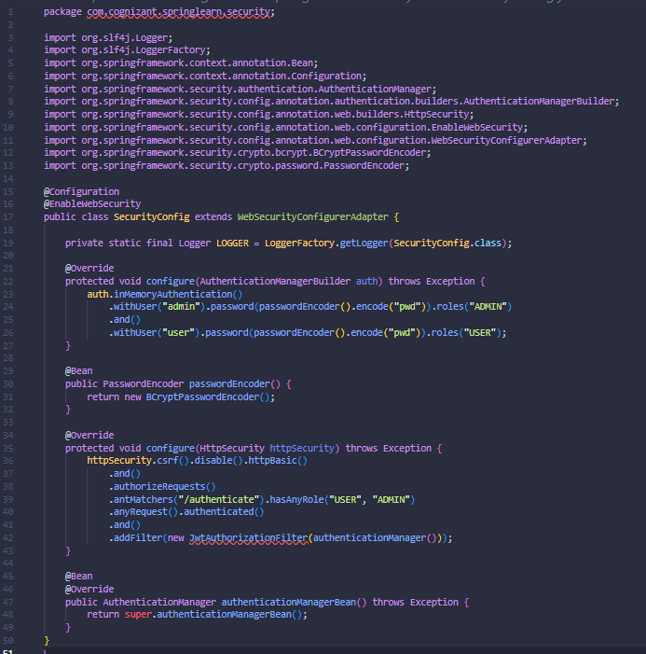

**Step 4: Create JWT Filter for Authorization**

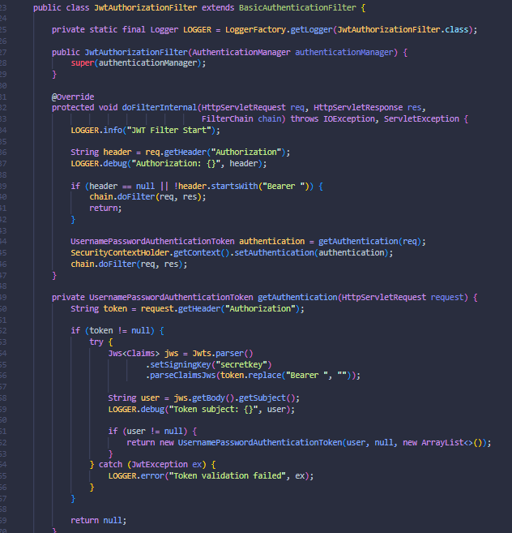

**Test your Implementation:**

**Use:**

**curl -s -u user:pwd** [**http://localhost:8090/authenticate**](http://localhost:8090/authenticate)

**Access Secure API with JWT:**

**curl -s -H "Authorization: Bearer <JWT_TOKEN>" http://localhost:8090/countries**